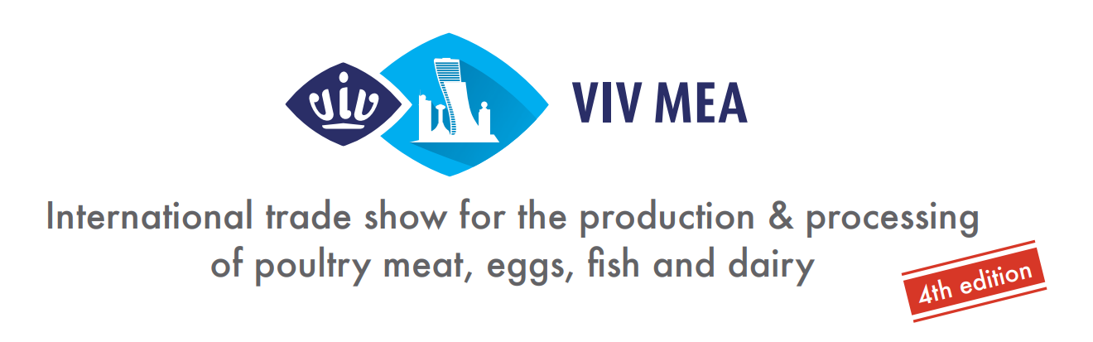

Press Release
[ Utrecht – the Netherlands, October 19th, 2022]

FOOD SECURITY & SUSTAINABLE AGRICULTURE AT THE HEART OF THE MIDDLE EAST STRATEGIC DEVELOPMENT
VIV MEA is the leading event to stay ahead of new technologies and market trends. The city of Abu Dhabi welcomes VIV MEA visitors and exhibitors from all over the world.
The 4th edition of VIV MEA, the international trade show from feed to food for the production & processing of poultry meat, eggs, fish and dairy in the Middle East and Africa, takes place from
20-22 November 2023. VIV MEA brings together the livestock world with 500+ global and regional suppliers from the entire supply chain of all animal species production. Strongly business-driven, with a clear focus on innovation, technology and scientific research, VIV MEA is by far the top show for the animal husbandry industry in the whole region since 2016 when the first edition took place.
Alongside the VIV MEA trade show, wholly focused on animal based protein as usual, the organizer VNU Europe will separately bring extra contents and products from suppliers of controlled environments and precision agriculture as well as innovations and technologies for smart food production, covering topics such as: plant based protein production; improved nutritional value and health; organic food concepts; increase yields programs; control pests solutions; water saving systems; energy use management; and more.
“At VIV MEA, we strive to bring delegations and industry leaders from all over the world to share their global perspective on a variety of agri-food topics. In fact, we are looking forward to welcoming approximately 8,000 visitors from around the world, and especially from the GCC,” affirmed Mrs. Renate Wiendels, Senior Project Manager, VIV worldwide.
VNU Europe invites all professionals in the field to save the date for an event of business networking, knowledge and future-focused discussions shaping the next standards in agri-food production.
See you at ADNEC in Abu Dhabi, U.A.E. from 20-22 November 2023.

----------------------------------------------------- End of Press release -----------------------------------------------------

Press contacts:
Ms. Elena Geremia, Senior Marcom Manager at VIV worldwide, elena@vnueurope.com

About VIV worldwide | VIV worldwide is the business network linking professionals from feed to food, offering boundless opportunities to the animal protein supply chain players. VIV worldwide developed with dedication a network through 40 years of experience and interactions with the industry, making it the leading platform for some of the most promising markets of the world. Visit WWW.VIV.NET.

About VNU Europe | VNU Europe is a subsidiary company of Royal Dutch Jaarbeurs with its base in Utrecht, at the heart of the Netherlands and only 30 minutes from Amsterdam. The VNU Europe office is located within the extensive Jaarbeurs complex. The international team of VNU Europe is wholly focused on the livestock and Feed to Food sector and specialized in the VIV worldwide portfolio. For more information, visit www.vnueurope.com

