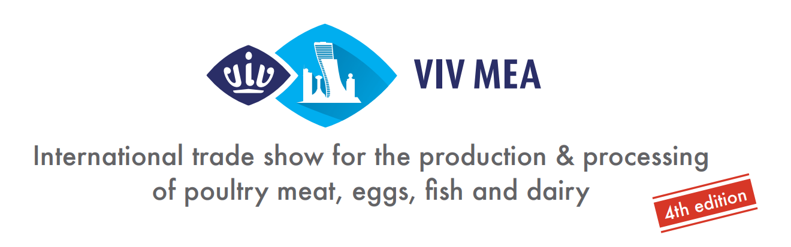

Press Release
[ Utrecht – the Netherlands, May ^{1st}, 2023]

NEW! HORTI AGRI NEXT to join VIV MEA 2023 in Abu Dhabi!

VIV MEA, the international trade show from feed to food for the production & processing of poultry meat, eggs, fish, and dairy, in the Middle East and Africa, returns for its 4th edition
20-22 November 2023, in Abu Dhabi. VIV MEA brings together the livestock world with 500+ global and regional suppliers from the entire supply chain of all animal species production. Strongly business-driven, with a clear focus on innovation, technology and scientific research, VIV MEA is by far the top show for the animal husbandry industry in the whole region since 2016 when the first edition took place.
Smart Horticulture And Sustainable Agriculture In The Epicenter Of The Middle East Agri-Food Business Week

Parallel to VIV MEA 2023, two new concepts are showing up to complement a rich portfolio: HORTI AGRI NEXT (HAN) MEA 2023. This new co-located show will bring for the first time an array of exhibitors and brand names from the horticultural, agricultural, and plant-based protein production and processing industry, in the heart of the Middle East. The first edition of HAN MEA aspires to be an international platform for all professionals in the agri-business in the region that will bring new products, innovations, and technologies to an ever-growing audience.
The Abu Dhabi Agriculture & Food Security Week is back for the second time in November 2023
The Abu Dhabi Agriculture & Food Security Week (ADAFSW) was launched for the first time in 2021 by the Government entity Abu Dhabi Agriculture & Food Safety Authority (ADAFSA). It has since its launch been recognized as the largest event of its kind in the region, bringing together farmers and growers, food producers, policy makers, scientists, and investors with the ultimate goal of moving forward in sustainable agriculture and food security.

Following a valuable first edition, ADAFSA announced a cooperation with VNU Europe, the organizer of the VIV worldwide series of events - including VIV MEA, to bring the Abu Dhabi Agriculture & Food Security Week to the next level. Within this concept, there is no better timing and stage for the launching of HORTI & AGRI NEXT MEA exhibition that will be covering – together with the well-established VIV MEA – the entire AgriFood supply chain, both horizontally and vertically.

VNU Europe invites all professionals in the field to save the date for an event of business networking, knowledge and future-focused discussions shaping the future and new standards in the agri-food production.

----------------------------------------------------- End of Press release -----------------------------------------------------

Press contacts:
Ms. Lida Kokkini, Senior Marcom Manager at VIV worldwide, lida@vnueurope.com

About VIV worldwide | VIV worldwide is the business network linking professionals from feed to food, offering boundless opportunities to the animal protein supply chain players. VIV worldwide developed with dedication a network through 40 years of experience and interactions with the industry, making it the leading platform for some of the most promising markets of the world. Visit WWW.VIV.NET.

About VNU Europe | VNU Europe is a subsidiary company of Royal Dutch Jaarbeurs with its base in Utrecht, at the heart of the Netherlands and only 30 minutes from Amsterdam. The VNU Europe office is located within the extensive Jaarbeurs complex. The international team of VNU Europe is wholly focused on the livestock and Feed to Food sector and specialized in the VIV worldwide portfolio. For more information, visit www.vnueurope.com

